Guvi Zen Class DB design

Introduction

This database manages students and mentors, tracking their details, tasks, queries, and class schedules.

Entities:

1. Students Details: ID, Name, Age, Course, Email, Joining Date, Duration

2. Mentors Details: ID, Name, Age, Email, Joining Date, Subject Taught

3. Task submissions Details: Submission ID, Student Name, Course, Task, Marks, Submission Date

4. Mentor queries Details: Query ID, Student Name, Query, Date Raised, Status, Mentor Assigned

5. Mentor class timings Details: Class Timing ID, Course, Timing, Date

6. Student mentors Details: Student ID, Mentor ID (links students to their mentors based on course)

Relationships:

• Students and Mentors: Students are matched with mentors based on their course and the mentor’s subject.

• Tasks: Each student can have multiple tasks recorded.

• Queries: Each query is linked to a student and handled by a mentor.

• Class Timings: Each mentor’s classes are scheduled with timings and dates.

create schema Guvi;

use Guvi;

create table students(

student_id int auto_increment primary key,

name varchar(255),

age int,

course varchar(255),

email varchar(255),

date_of_joining date,

duration varchar(20)

);

insert into students (name, age, course, email, date_of_joining, duration) values

('Karthikeyan', 25, 'MERN stack development', 'karthi@guvi.com', '2024-04-21', '6 months'),

('Gokul', 25, 'Business Intelligence', 'gokul@guvi.com', '2024-02-21', '3 months'),

('Issac', 25, 'MERN stack development', 'issac@guvi.com', '2023-11-18', '3 months'),

('Abidh', 25, 'Python developer', 'abidh@guvi.com', '2024-05-10', '6 months'),

('Divyadharshini', 22, 'UI/UX Designer', 'divi@guvi.com', '2024-08-21', '5 months'),

('Kavya', 22, 'Data analytics', 'kavya@guvi.com', '2024-07-20', '3 months'),

('Sabari', 25, 'Data Science', 'sabari@guvi.com', '2024-05-05', '4 months'),

('selsia', 25, 'PHP developer', 'selsia@guvi.com', '2024-03-08', '6 months'),

('Dharshini', 24, 'Java developer', 'dharshini@guvi.com', '2023-10-28', '8 months'),

('Vinitha', 25, 'Angular developer', 'vinitha@guvi.com', '2024-06-15', '6 months');

create table tasks(

task_id int auto_increment primary key,

student_id int,

course varchar(50),

task_description varchar(100),

foreign key (student_id) references Students(student_id)

);

insert into tasks (student_id, course, task_description) values

(1, 'MERN stack development', 'Design a DB model for Guvi Zen'),

(2, 'Business Intelligence', 'Market Basket Analysis'),

(3, 'MERN stack development', 'Design a DB model for Guvi Zen'),

(4, 'Python developer', 'Password Generator'),

(5, 'UI/UX Designer', 'Design a UI for ecommerce'),

(6, 'Data analytics', 'Sales Forecasting Analysis'),

(7, 'Data Science', 'Hospital Treatment Pricing Prediction'),

(8, 'PHP developer', 'Leave Management System in PHP'),

(9, 'Java developer', 'Currency Converter'),

(10, 'Angular developer', 'Blog App');

create table queries(

query_id int auto_increment primary key,

student_id int,

query varchar(255),

status varchar(255),

date_of_query_raised DATE,

assigned_to varchar (50),

foreign key (student_id) references Students(student_id)

);

insert into queries (student_id, query, date_of_query_raised, status, assigned_to) values

(1, 'Doubt in sql', '2024-05-21', 'Solved', 'Vikram'),

(2, 'Issue with data visualization', '2024-03-21', 'Pending', 'Amar'),

(3, 'Doubt in sql', '2023-12-18', 'Solved', 'Bijoy'),

(4, 'Issue password generating', '2024-06-10', 'Pending', 'Santhanam'),

(5, 'Designing issue in Adobe', '2024-08-20', 'Solved', 'Dilli'),

(6, 'Issue with data visualization', '2024-07-28', 'Pending', 'Parthiban'),

(7, 'Issue in pricing prediction', '2024-05-10', 'Solved', 'Vikram'),

(8, 'Doubt in leave management system data', '2024-04-21', 'Pending', 'Amar'),

(9, 'Api fetching issue', '2023-11-21', 'solved', 'Santhanam'),

(10, 'Doubt on creating a blog app', '2024-07-28', 'Pending', 'Bijoy');

create table ClassTimings(

class_timing_id int auto_increment primary key,

student_id int,

time_of_class Time,

date Date,

foreign key (student_id) references Students(student_id)

);

insert into ClassTimings( student_id, time_of_class, date) values

(1, '21:00:00', '2024-07-12'),

(2, '11:00:00', '2024-06-18'),

(3, '14:00:00', '2024-07-20'),

(4, '16:00:00', '2024-07-05'),

(5, '18:00:00', '2024-06-28'),

(6, '10:00:00', '2024-07-12'),

(7, '15:00:00', '2024-06-30'),

(8, '20:00:00', '2024-07-14'),

(9, '13:00:00', '2024-06-25'),

(10, '19:00:00', '2024-07-22');

create table Feedbacks (

feedback_id INT AUTO_INCREMENT PRIMARY KEY,

student_id INT,

feedback TEXT,

date DATE,

foreign key (student_id) REFERENCES Students(student_id)

);

insert into Feedbacks (student_id, feedback, date) values

(1, 'Excellent flow of covering topics', '2024-07-11'),

(2, 'Good hands-on practice', '2024-06-30'),

(3, 'More examples needed', '2024-07-05'),

(4, 'Great support from mentors', '2024-07-02'),

(5, 'Course pacing is fast', '2024-06-20'),

(6, 'Enjoyed the interactive sessions', '2024-07-09'),

(7, 'Detailed explanations appreciated', '2024-07-13'),

(8, 'Loved the practical projects', '2024-07-19'),

(9, 'More focus on advanced topics required', '2024-07-07'),

(10, 'Satisfied with the course content', '2024-07-15');

create table PerformanceReports (

report_id INT AUTO_INCREMENT PRIMARY KEY,

student_id INT,

task_percentage DECIMAL(5,2),

foreign key (student_id) REFERENCES Students(student_id)

);

insert into PerformanceReports (student_id, task_percentage) values

(1, 80.00),

(2, 90.00),

(3, 85.00),

(4, 78.00),

(5, 92.00),

(6, 87.00),

(7, 88.00),

(8, 81.00),

(9, 70.00),

(10, 95.00);

Query 1: Get student details along with their course and duration

select name, course, duration from Students;

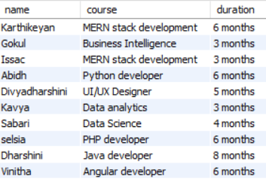

Query 2: Get tasks assigned to each student

SELECT s.name, t.task_description

FROM Students s

JOIN Tasks t ON s.student_id = t.student_id;

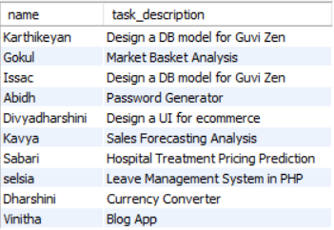

Query 3: Get class timings for each student

SELECT s.name, ct.time_of_class, ct.date

FROM Students s

JOIN ClassTimings ct ON s.student_id = ct.student_id;

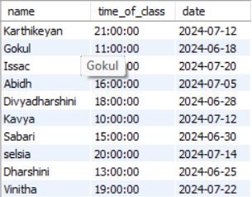

Query 4: Get students who have completed their tasks with a percentage above 85

SELECT s.name, pr.task_percentage

FROM Students s

JOIN PerformanceReports pr ON s.student_id = pr.student_id

WHERE pr.task_percentage > 85;

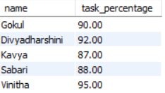

Query 5: Get the average task percentage for each course

SELECT s.course, AVG(pr.task_percentage) as avg_task_percentage FROM Students s JOIN PerformanceReports pr ON s.student_id = pr.student_id GROUP BY s.course;

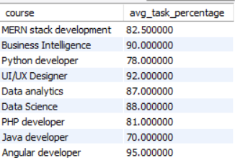

Query 6: Get the count of students enrolled in each course

SELECT course, COUNT(*) as student_count FROM Students GROUP BY course;

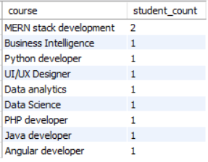

Query 7: Get Students with Pending Queries and Their Assigned Mentors

SELECT s.student_id, s.name, q.query, q.assigned_to FROM Students s JOIN Queries q ON s.student_id = q.student_id WHERE q.status = 'Pending';

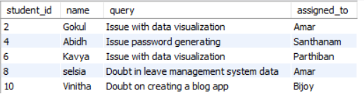

Mentors DB

create table Mentors (

mentor_id INT AUTO_INCREMENT PRIMARY KEY,

name VARCHAR(50),

age INT,

email VARCHAR(100),

date_of_joining DATE,

teaching VARCHAR(50)

);

insert into Mentors (name, age, email, date_of_joining, teaching)

VALUES

('Vikram', 31, 'vikram@guvi.com', '2022-04-12', 'MERN stack development'),

('Amar', 35, 'amar@guvi.com', '2022-01-10', 'Business Intelligence'),

('Santhanam', 40, 'santhanam@guvi.com', '2021-11-25', 'Python developer'),

('Bijoy', 29, 'bijoy@guvi.com', '2023-02-18', 'MERN stack development'),

('Parthiban', 33, 'parthiban@guvi.com', '2022-07-15', 'Data analytics'),

('Dilli', 37, 'dilli@guvi.com', '2021-12-05', 'UI/UX designer'),

('Surya', 38, 'surya@guvi.com', '2022-08-20', 'Machine Learning'),

('Sunita', 32, 'sunita@guvi.com', '2023-03-30', 'Mobile App Development'),

('Manoj', 34, 'manoj@guvi.com', '2022-05-18', 'Blockchain Technology'),

('Neha', 28, 'neha@guvi.com', '2023-01-14', 'Game Development');

create table TaskSubmissions (

submission_id INT AUTO_INCREMENT PRIMARY KEY,

student_name VARCHAR(50),

course VARCHAR(50),

task VARCHAR(255),

marks DECIMAL(5,2),

date_of_submission DATE

);

insert into TaskSubmissions (student_name, course, task, marks, date_of_submission) values

('Karthikeyan', 'MERN stack development', 'Design a DB model for Guvi Zen', 75, '2024-06-12'),

('Gokul', 'Business Intelligence', 'Market Basket Analysis', 85, '2024-06-15'),

('Issac', 'MERN stack development', 'Design a DB model for Guvi Zen', 90, '2024-06-20'),

('Abidh', 'Python developer', 'Password Generator', 80, '2024-07-01'),

('Divyadharshini', 'UI/UX Designer', 'Design a UI for ecommerce',88, '2024-07-03'),

('Kavya', 'Data analytics', 'Sales Forecasting Analysis',92, '2024-06-25'),

('Sabari', 'Data Science', 'Hospital Treatment Pricing Prediction',84, '2024-07-05'),

('selsia', 'PHP developer', 'Leave Management System in PHP', 87, '2024-06-30'),

('Dharshini', 'Java developer', 'Currency Converter', 78, '2024-07-10'),

('Vinitha', 'Angular developer', 'Blog App',95, '2024-07-15');

create table MentorQueries (

query_id INT AUTO_INCREMENT PRIMARY KEY,

student_name VARCHAR(50),

query VARCHAR(255),

date_of_query_raised DATE,

status VARCHAR(20),

assigned_to VARCHAR(50)

);

insert into MentorQueries (student_name, query, date_of_query_raised, status, assigned_to) values

(1, 'Doubt in sql', '2024-05-21', 'Solved', 'Vikram'),

(2, 'Issue with data visualization', '2024-03-21', 'Pending', 'Amar'),

(3, 'Doubt in sql', '2023-12-18', 'Solved', 'Bijoy'),

(4, 'Issue password generating', '2024-06-10', 'Pending', 'Santhanam'),

(5, 'Desigining issue in Adobe', '2024-08-20', 'Solved', 'Dilli'),

(6, 'Issue with data visualization', '2024-07-28', 'Pending', 'Parthiban'),

(7, 'Issue in pricing prediction', '2024-05-10', 'Solved', 'Vikram'),

(8, 'Doubt in leave management system data', '2024-04-21', 'Pending', 'Amar'),

(9, 'Api fetching issue', '2023-11-21', 'solved', 'Santhanam'),

(10, 'Doubt on creating a blog app', '2024-07-28', 'Pending', 'Bijoy');

create table MentorClassTimings (

class_timing_id INT AUTO_INCREMENT PRIMARY KEY,

course VARCHAR(50),

timing TIME,

date DATE

);

insert into MentorClassTimings (course, timing, date) values

('MERN stack development', '21:00:00', '2024-07-12'),

('Data Science', '11:00:00', '2024-06-18'),

('Data analytics', '14:00:00', '2024-07-20'),

('Cloud Computing', '16:00:00', '2024-07-05'),

('PHP developer', '18:00:00', '2024-06-28'),

('Business Intelligence', '10:00:00', '2024-07-12'),

('Python developer', '15:00:00', '2024-06-30'),

('UI/UX designer', '20:00:00', '2024-07-14'),

('Java developer', '13:00:00', '2024-06-25'),

('Angular developer', '19:00:00', '2024-07-22');

Query: - Find the Mentors with the Oldest Age

SELECT name, age, email

FROM Mentors

ORDER BY age DESC

LIMIT 3;

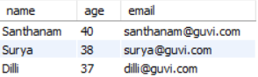

Query:-List Mentors with Their Email and Teaching Field in Alphabetical Order

SELECT name, email, teaching AS course FROM Mentors ORDER BY name ASC;

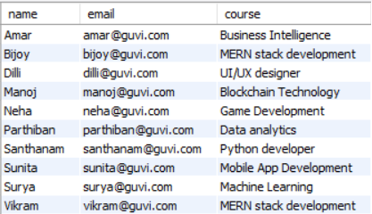

Query:- Pending Queries

SELECT student_name, query, date_of_query_raised, assigned_to FROM MentorQueries WHERE status = 'Pending';

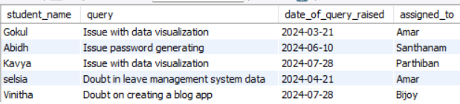

Query:- Queries Raised Before a Certain Date

SELECT student_name, query, date_of_query_raised, status, assigned_to FROM MentorQueries WHERE date_of_query_raised < '2024-07-01';

